Night Of
Managed Care

Monday, March 7th 2016
Western University of Health Sciences
Academy of Managed Care Pharmacy student chapter

Featured Guests

Dr. Marshal Abdullah  *** Keynote Speaker***  AMCP Southern California State Advocacy Coordinator  Dr. Clarence Chung  Pharmacy Medical Director for Formulary and Utilization,  IEHP  Dr. Jorge Farias  Sr. Pharmacy Account Specialist, Sanofi  Dr. Raffi Kaprielian  Director of Pharmacy Services, Regal Medical Group  Dr. Erica Lai  Managed Care Pharmacist,  Brand New Day Health Plan | Dr. Long Ma  Pharmacy Account Specialist, AstraZeneca  Dr. Joanne Nguyen  Medical Science Liaison, Boehringer Ingelheim  Dr. Robert Olegario  Clinical Pharmacist, Healthnet  Dr. George Tran  Formulary Pharmacy Manager, Anthem  Dr. David Truong  Regulatory Affairs Manager, Teva  Dr. Kimberly Tsai  Managed Care Pharmacist,  Greater Newport Physicians, Memorial Care Center

Agenda of the day

6:00 - 6:15 pm  6:15 - 6:30 pm  6:30 - 6:35 pm  6:35 - 7:30 pm  7:30 - 7:35 pm  7:35 - 8:50 pm  8:50 - 9:00 pm | Check-In  Keynote Speaker  Round Table Explanation  Round Table Discussion  5-minute break  Round Table Continuation  Closing of the Night of Managed Care

Dr. Marshal Abdullah
*** Keynote Speaker ***
AMCP Southern California State Advocacy Coordinator

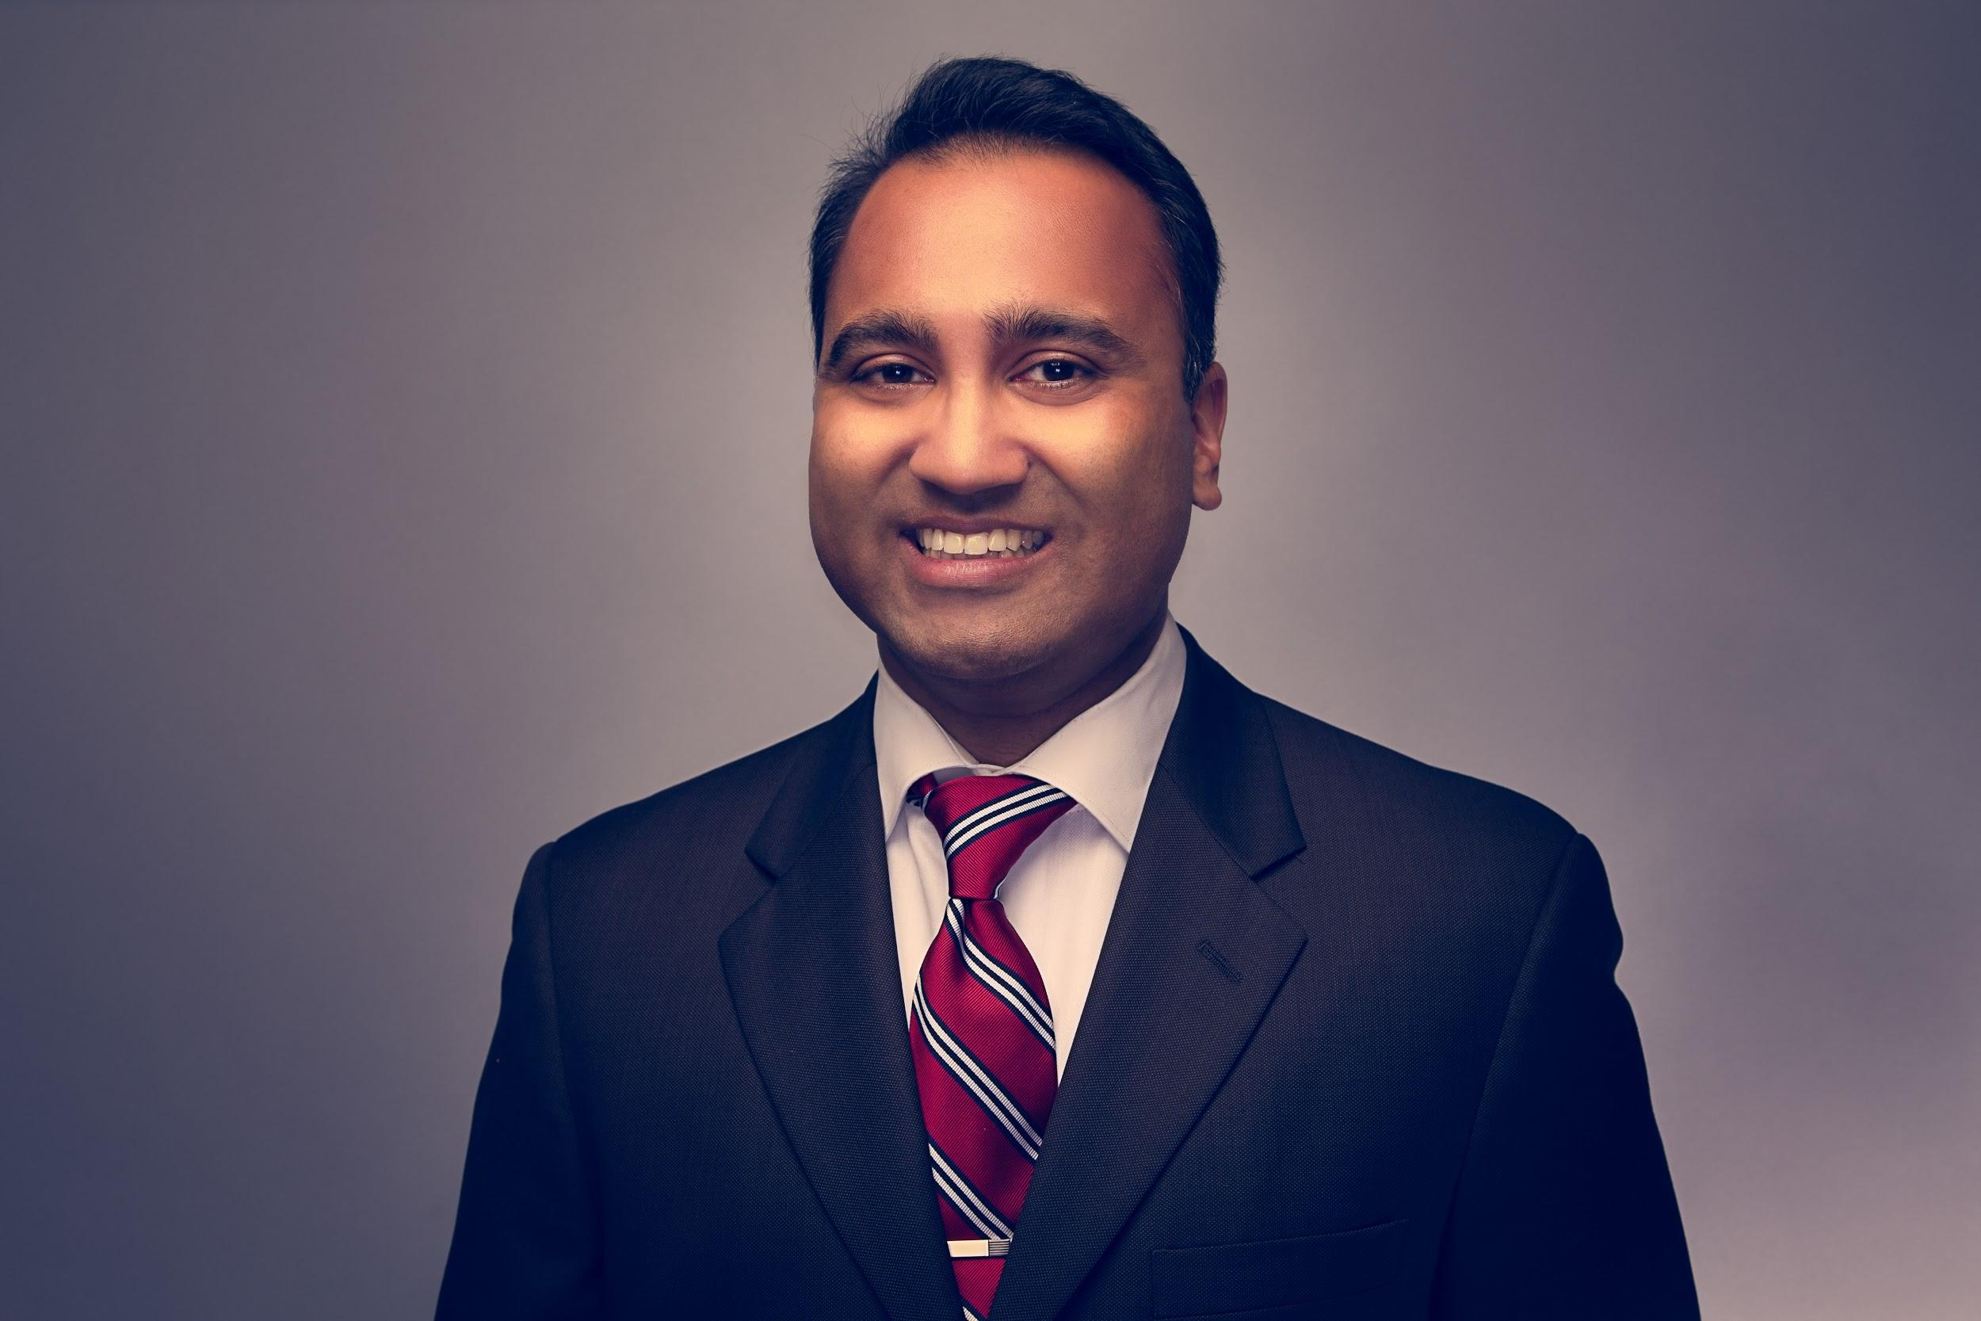

Dr. Marshal Abdullah is a second generation pharmacist who is currently working in the community pharmacy practice setting in the Los Angeles area. He earned his Doctor of Pharmacy degree from the University of Southern California, School of Pharmacy in 2008. He is closely associated with Mickey Fine Pharmacy spending half of his time providing pharmaceutical care and the other half on program development for their multiple locations. His involvements with the Academy of Managed Care Pharmacists include serving on the Legislative and Regulatory Action Committee along with continuing on a second term as the State Advocacy Coordinator for California. He was nationally recognized as the recipient of AMCP’s Grassroots Advocacy Award in 2014 for revitalizing the look of grassroots advocacy by creating multiple communication channels to increase participation. Dr. Abdullah’s previous working experiences primarily include being the Student Pharmacist Development Liaison for the California Pharmacists Association in Sacramento, working as an Executive Team Lead with Target Pharmacies in Southern California, and working in managed care with Hill Physicians Medical Group in San Ramon and Blue Shield of California in San Francisco. Marshal’s future endeavors involve balancing a life of traveling with advancing his interests in primary care development.

Dr. Clarence Chung
Pharmacy Medical Director for Formulary and Utilization, IEHP

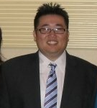

Dr. Clarence Chung is a Pharmacy Medical Director at Inland Empire Health Plan (IEHP). He received his B.S. from UCSD and Pharm.D/MBA from the University of Maryland. Upon graduation, Dr. Chung accepted a position with Rite Aid Pharmacy to open a new store location and succeeded in growing the business to 300 scripts/day within 6 months. Dr. Chung then returned from Maryland to California to take a position with Prescription Solutions (now known as OptumRx), a pharmacy benefit management organization, as part of the drug information team responsible for clinical monograph and P&T processes before transitioning to formulary management, pipeline, and rebate review. In 2009, Dr. Chung accepted a position as clinical pharmacist with IEHP to assist in reviewing prior authorizations and clinical programs. During his time at IEHP, Dr. Chung has had direct responsibility over clinical programs, financial, utilization, and formulary management overseeing a growth from 300,000 to over 1.1 million member lives across 4 distinct lines of business.

Dr. Jorge Farias
Sr. Pharmacy Account Specialist, Sanofi

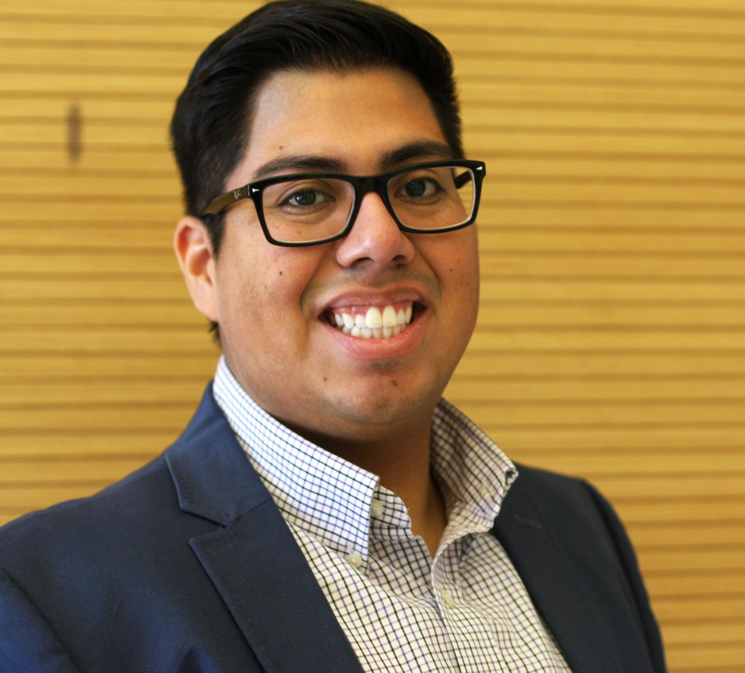

Dr. Jorge Farias received his Doctor of Pharmacy degree in 2013 from the University of Southern California. After graduation, Dr. Farias pursued a career in the pharmaceutical industry as a Community Pharmacy Liaison with Sanofi. Dr. Farias is responsible for partnering with major retail pharmacy chains on programs that advance the ability of pharmacists to deliver care to their patients. This includes training community pharmacists on new drugs, devices, and vaccines from Sanofi and putting together educational talks for pharmacists. He is also serving as a member of the executive board for the Orange County Pharmacists Association, alumni advisor for the University of Southern California's Latinos in Pharmacy, and a member of CPhA's Grassroots Committee, and the Deans Advisory Council at Marshall B Ketchum University's School of Pharmacy.

Dr. Raffi Kaprielian
Director of Pharmacy Services, Regal Medical Group

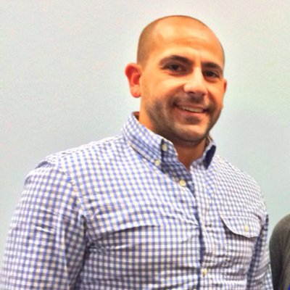

Dr. Raffi Kaprielian is the Vice President of Pharmacy Services at Regal Medical Group & Affiliated Doctors of Orange County in the Los Angeles area. Dr. Kaprielian received his Doctor of Pharmacy degree in 2007 from Western University of Health Sciences. He currently oversees all pharmacy operations of high risk programs, case management, industry relations, utilization management and nurse teams to improve therapeutic outcomes across all lines of business including HMO (Health Maintenance Organization) and ACO (Accountable Care Organization), with membership under duals demonstrations, Cal Medi-Connect and Medi-Cal. His previous working experiences involve being an consultant pharmacist at RK Pharmacy Consulting, Community Pharmacist at Safeway, and Pharmacy Services Manager for Medicare Advantage HMO plan at Arcadian Health Plan.

Dr. Erica Lai
Managed Care Pharmacist, Brand New Day Health Plan

Dr. Erica Lai received her Doctor of Pharmacy degree from University of Southern California in 2014. She currently works at Brand New Day, a Medicare Health Plan located in Garden Grove, CA. Her job duties include medication review for care of older adults, medication recommendation post discharge, assist with Medi-Cal prior authorization requests, review MediCare appeals, and assist with Medicare Part B and D benefit issues.

Dr. George Tran
Formulary Pharmacy Manager, Anthem

Dr. George Tran is the Clinical Pharmacist for Cost of Care Anthem. Dr. Tran received his Doctor of Pharmacy degree in 2003 from Western University of Health Sciences. His previous working experiences involves in Lead Pharmacist Formulary Management at WellPoint, Clinical Oncology Pharmacist at Kaiser in Anaheim, and Director of Pharmacy at Las Encinas Hospital. Also Dr. Tran completed his Residency in VA at Loma Linda in 2004.

Dr. Long Ma
Pharmacy Account Specialist, AstraZeneca

Dr. Long Ma graduated in 2005 with a Doctor of Pharmacy degree from the University of Southern Nevada School of Pharmacy (now Roseman University School of Pharmacy). After graduating, he worked in retail after graduating but kept asking himself if what he was doing was enough. He decided to venture out into other fields and worked as a sales/marketing manager at a highly recognized independent pharmacy in Orange County where he managed a sales team and personally trained his team in the greater knowledge of diabetic supplies, durable medical equipment (DME). Dr. Long Ma later went on to obtain his certification in compounding from the prestigious organization Professional Compounding Center of America (PCCA) in Sugarland, TX. He has now found home with Astra Zeneca as a Pharmacy Account Specialist. His role entails getter in contact with higher management of all known community pharmacies and educating them diabetic medications followed with the adjudication process for each of our products. Another objective is to keep pharmacists up to date with the most current information out there through my diabetes portfolio at Astra Zeneca. This is done so through presentations and meetings we conduct and also through speaker dinner programs offered to all our pharmacists.

Dr. Joanne Nguyen
Medical Science Liaison, Boehringer Ingelheim

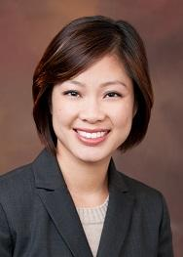

Joanne Nguyen is a Medical Science Liaison at Boehringer Ingelheim. She has experience in several functional areas in Pharmaceutical Industry such as Translational Medicine, Medical Information and Communication, and Field Based Medicine. Companies she has worked for include Novartis, Bristol-Meyers Squibb, Fresenius Medical Care and Boehringer Ingelheim. She studied Biology as an undergraduate at UCLA and went on to obtain her Masters in Biological Sciences at Cal State University, Los Angeles. She received her Doctor of Pharmacy degree at Western University of Health Sciences in 2012 and thereafter, completed a Pharmaceutical Industry Postdoctoral Fellowship at Rutgers University in conjunction with Novartis.

Dr. Robert Olegario
Clinical Pharmacist, Healthnet

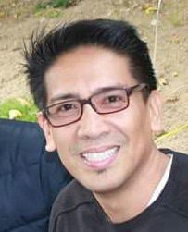

Dr. Robert Olegario currently serves as a clinical pharmacist at Health Net Pharmaceutical Services. In his current role, he spearheads a health plan’s national clinical program in meeting the Healthcare Effectiveness Plan Employer Data and Information Set (HEDIS) measure on the management of postmenopausal osteoporosis as indicated by the National Committee of Quality Assurance (NCQA) and a Medicare Part C Five-Star Rating measure. He participates in the Pharmacy and Therapeutics Committee in the preparation and presentation of drug monographs, adverse drug reaction reports, prior authorization protocols and clinical practice guidelines. He acts as a liaison between contracted medical groups and internal customers in addressing pharmacy related issues and creating solutions for members. Dr. Olegario has 20 years of experience in clinical pharmacy and pharmacy management including managed care, Medi-Cal HMO, pharmacy benefit management, long term care and hospital pharmacy. He has managed a prior authorization department and implemented national initiative, targeted disease intervention and pharmacy asthma program. He has conducted speaker programs for providers and pharmacists and participated in community programs. Dr. Olegario finished his pharmacy residency program at University of California Irvine Medical Center. He earned his Doctor of Pharmacy from the University of Southern California.

Dr. David Truong
Regulatory Affairs Manager, Teva

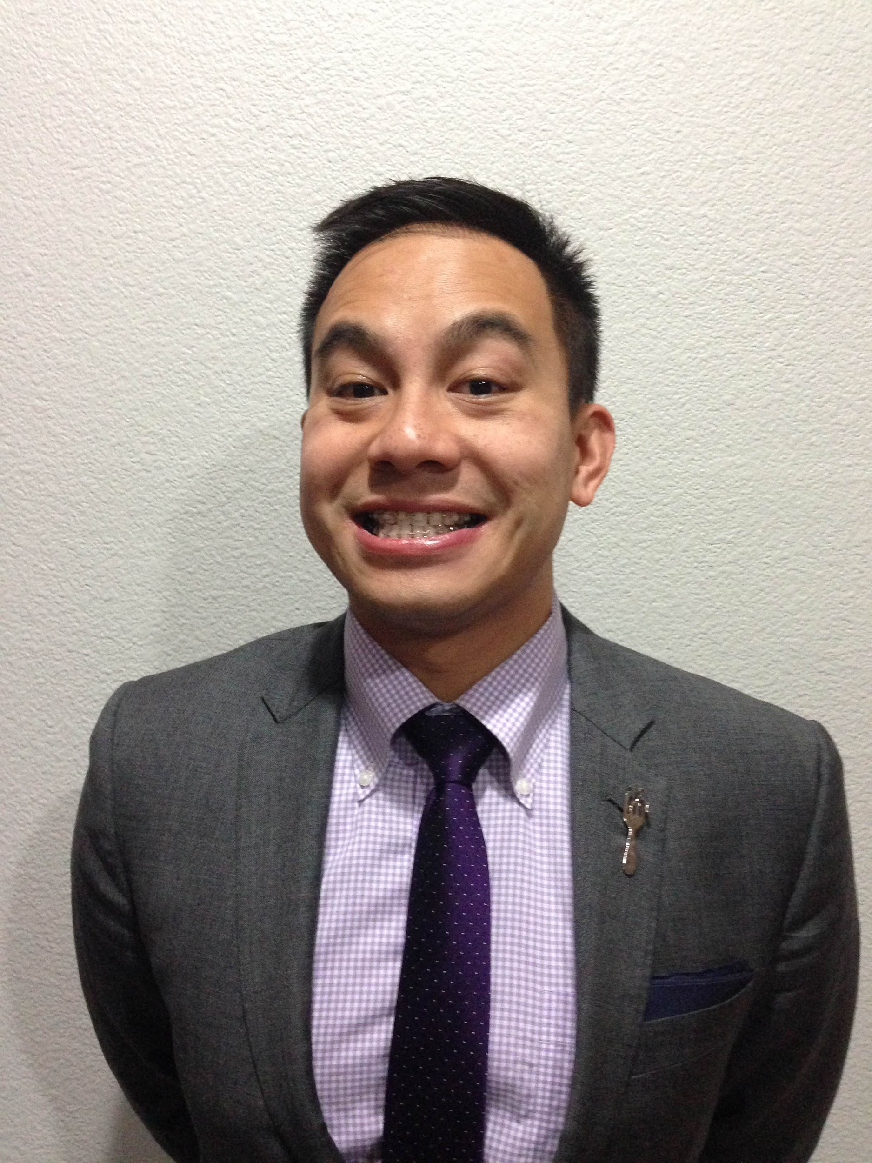

Dr. David Truong completed his Doctor of Pharmacy degree and Masters in Regulatory Science from the University of Southern California School of Pharmacy. He also completed two pharmaceutical industry fellowship programs with Allergan and USC. Dr. David Truong has held regulatory positions at Allergan Inc., Santarus Inc., and Auspex Pharmaceuticals. He is currently a Senior Manager in Regulatory Affairs at Teva Pharmaceuticals and also moonlights as a community pharmacist for Costco. In addition, he is the current President for the San Diego County Pharmacists Association (local affiliate of CPhA) and sits on the board for CPhA’s Academy of Managed Care.

Dr. Kimberly Tsai
Managed Care Pharmacist,
Greater Newport Physicians, Memorial Care Center

Dr. Kimberly Tsai is a Managed Care Pharmacist at Greater Newport Physicians, Memorialcare Medical Foundation. Comprised of nearly 900 affiliated physicians and specialists, GNP is an independent practice association which provides healthcare to more than 80,000 Southern California residents. Dr. Tsai also has pharmacy benefits management experience as a Clinical Pharmacist at OptumRx, tracking and presenting on drugs in the pipeline, developing and presenting monographs and prior authorization guidelines, and writing communications such as clinical news articles, and patient and provider letters. She has also completed a one year, ASHP- and AMCP-accredited managed care residency at OptumRx. Dr. Tsai is an active member of the Academy of Managed Care Pharmacy (AMCP). She currently serves as a member of the AMCP Membership Committee and as a peer reviewer for the Journal of Managed Care and Specialty Pharmacy. She has published research in the American Journal of Managed Care and Headache. Dr. Tsai earned her Bachelor of Science degree in General Biology and her Doctor of Pharmacy degree at the University of California, San Diego.

Notes

Thank you for coming!

